**ENR 161 Fall 2017 Chapter 7 Homework**

Name _________________________________________________ Grade ______________

Step 1:

Watch the Video Entitled, **Excel Ch07 HW F16**, this video is stored on the M drive at MCC and on youtube.com.

Step 2:

Complete the questions and problems below.

1. Describe what a bin is in the context of an Excel histogram.

2. What is unclear or ambiguous about the Bin numbers that appear on an Excel histogram? How can you resolve this problem?

3. How would a histogram change if the standard deviation of the sample were reduced?

4. What do the variables BL and BU represent in the worksheet in this chapter?

5. List the steps for adding error bars with lengths proportional to the standard deviation of the data point.

**Grade for Questions (0-10)** ______________________

**Problem Stamp or Grade**

**Pages 302-308, Frequency Worksheet** ______________________

1. Use the methods presented in Figures 7.8 to 7.20 to create the Frequency worksheet shown on the next two pages.

2. The sample resistances shown on the next page were created using the Random Number generator with the parameters shown below.

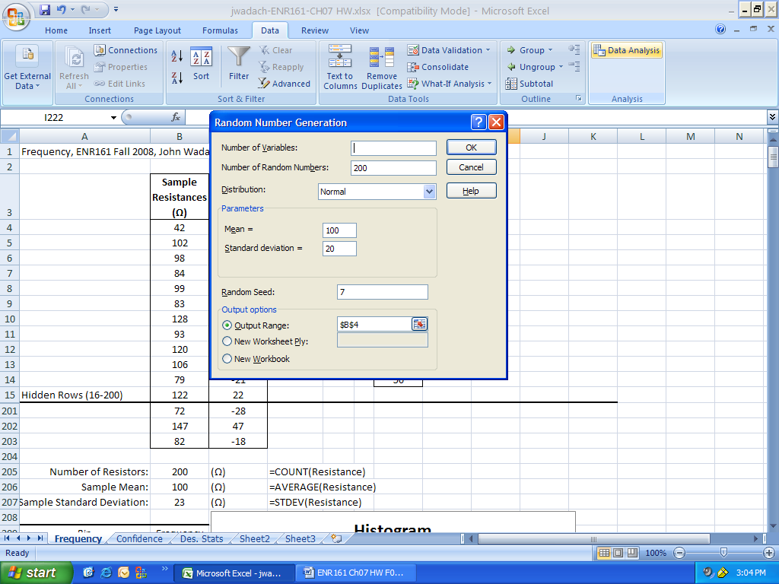

3. Format your sheet has shown below. Use the descriptive cell names and formulas as shown.

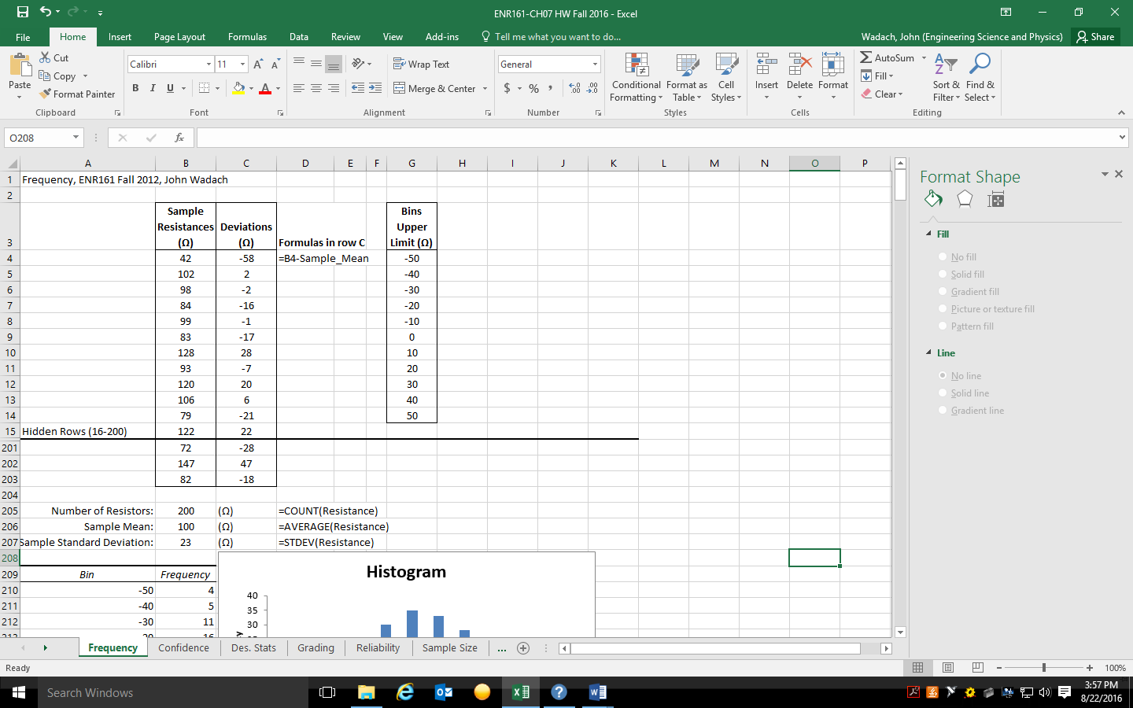

4. Create a Histogram beginning on the cell $A$209 as shown below. Note that I did not highlight the column labels and therefore did not check the labels box below.

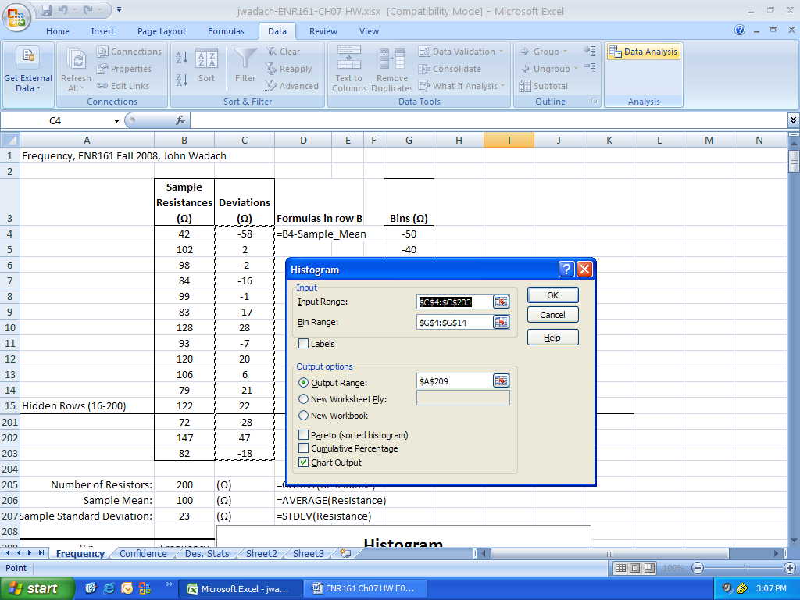

5. The histogram should appear as below.

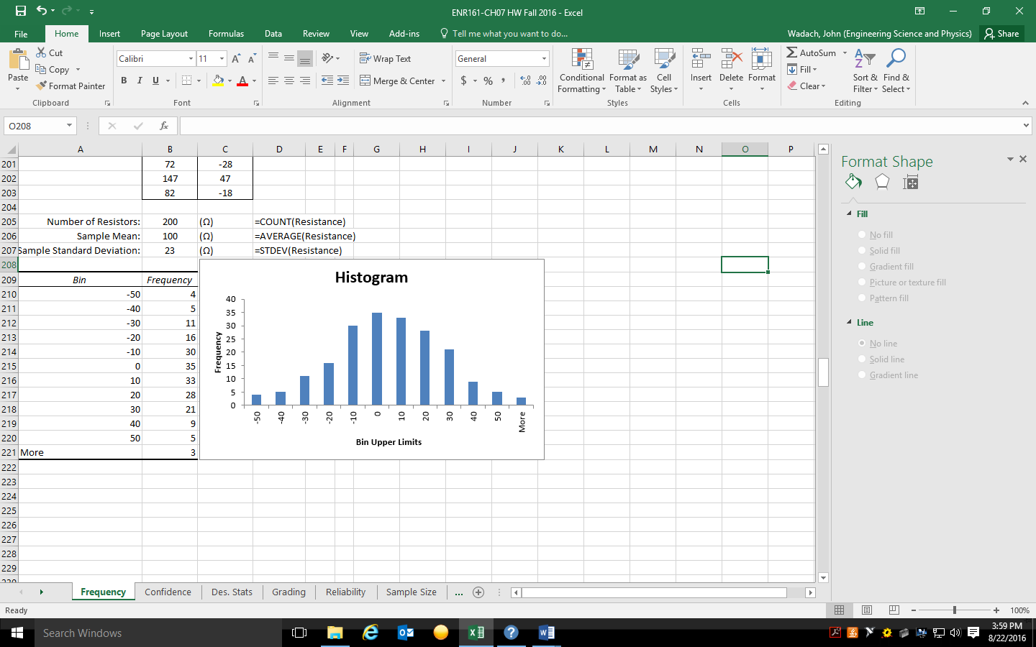

**Pages 309-313, Confidence Worksheet** ______________________

1. Copy the Resistance column from the Frequency Worksheet into this worksheet.

2. Use the operations presented in Figures 7.21 to 7.24 to create the Confidence worksheet.

3. Format the sheet and add descriptive cell names and formulas as shown below.

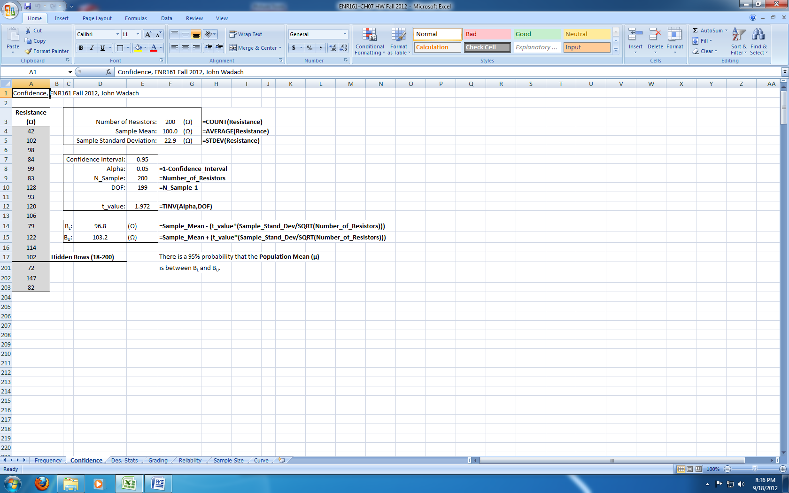

**Pages 313-315, Descriptive Statistics Worksheet** ______________________

1. Copy the Resistance column from the Confidence Worksheet into this worksheet.

2. Use the operations presented in Figures 7.25 to 7.27 to create the Descriptive Statistics worksheet.

3. The descriptive statistics table is created with the parameters shown below. Note that I did not highlight the table heading of the input range.

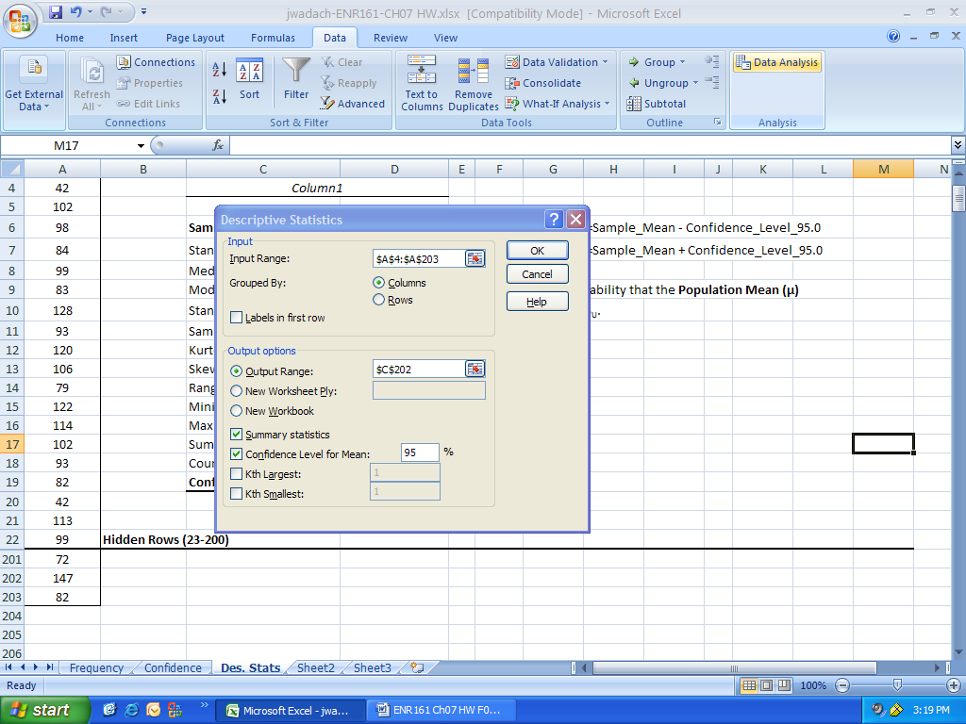

4. Format the sheet and add descriptive cell names and formulas as shown below.

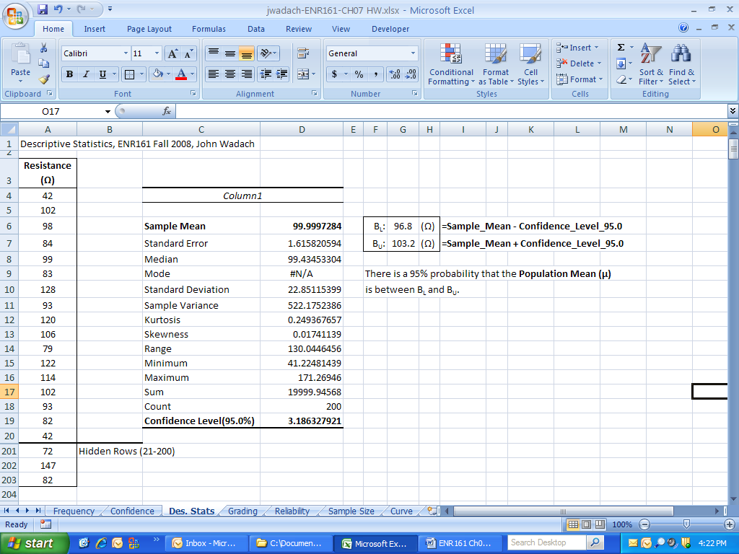

**Grading Worksheet** ______________________

1. Use the random number generator to create the test scores with a normal distribution and a mean of about 60 and standard deviation of about 15.

2. Compute the mean and standard deviation of the unrounded test scores.

3. The rounded scores must be computed using the ROUND() function.

4. Name the shaded cells in the table **GradeScale**. Name the Test Score Column **TestScores**.

5. Use the VLOOKUP() function to compute the letter grades. See page 209 in the text for an example of using this function.

6. Display the formulas for columns C and D in the cells with a black fill below. Your cells should not be blacked out like those below.

7. Create a Histogram using all **non-zero** values in the left column of the Grade Scale table for the bins.

8. Right click on the Histogram and click on Select Data and then edit the horizontal axis labels.

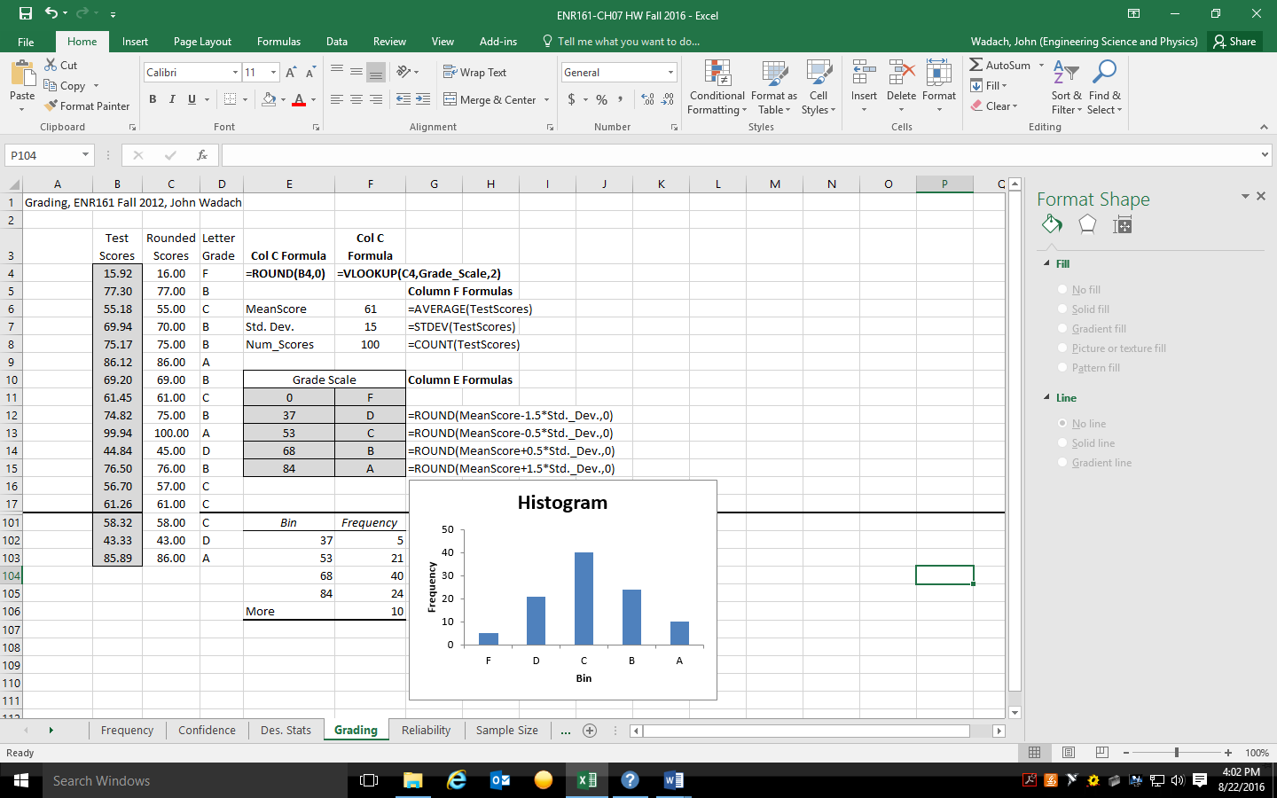

**Page 319, Problems 7.2 & 7.3, Reliability Worksheet** ______________________

1. The TC1 and TC2 data may be copied from the Chapter 7 Data.xlsx file located at: **M:\Courses\ENR\ENR 161\Excel- HW Data Files**

2. Complete problems 7.2 and 7.3 using named cells for the formulas in BL and BU. Format your sheet as shown below.

3. Be sure to answer the last question in 7.3 by typing it into the sheet below and highlighting in yellow.

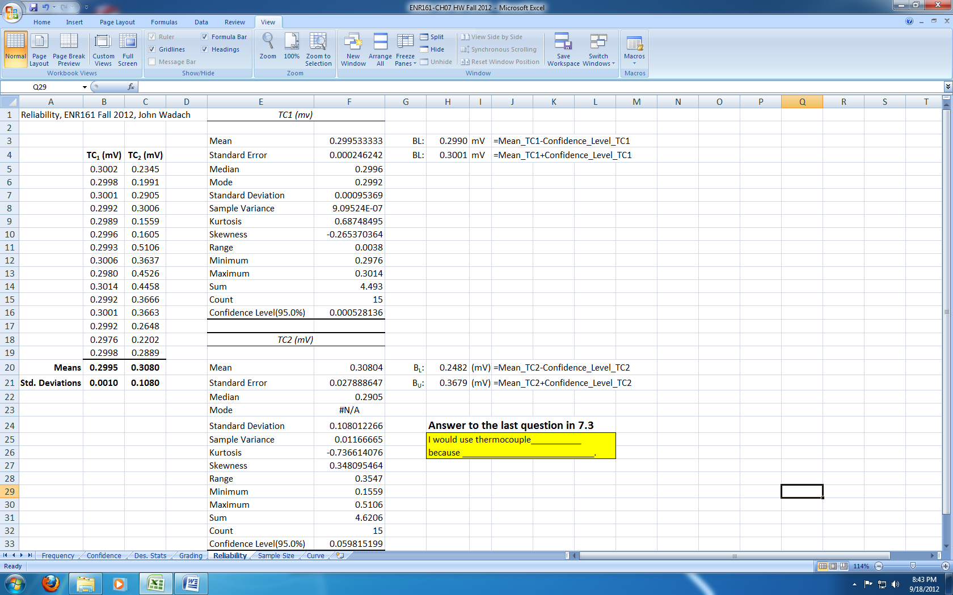

**Pages 319, Problem 7.4, Sample Size Worksheet** ______________________

1. The TCA data may be copied from the Chapter 7 Data.xlsx file located at: **M:\Courses\ENR\ENR 161\Excel- HW Data Files**

2. Complete problem 7.4 and also compute BL and BU for each data set. Format your sheet as shown below.

3. Be sure to answer question b by typing it into the sheet below and highlighting in yellow.

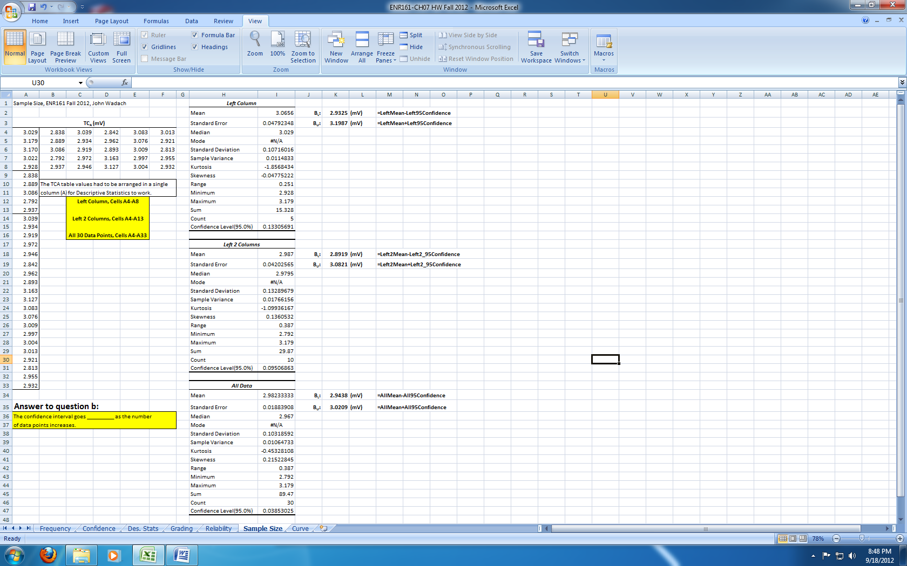

**Pages 320-321, Problem 7.5, Curve Worksheet** ______________________

1. The Thermocouple data may be copied from the Chapter 7 Data.xlsx file located at: **M:\Courses\ENR\ENR 161\ ENR161 Data Files**

2. Complete problems 7.5. Format your sheet as shown below.

3. To add the vertical error bars use a Custom error amount and Specify Values by selecting the Std. Dev. Column for both the Positive and Negative Error Values.

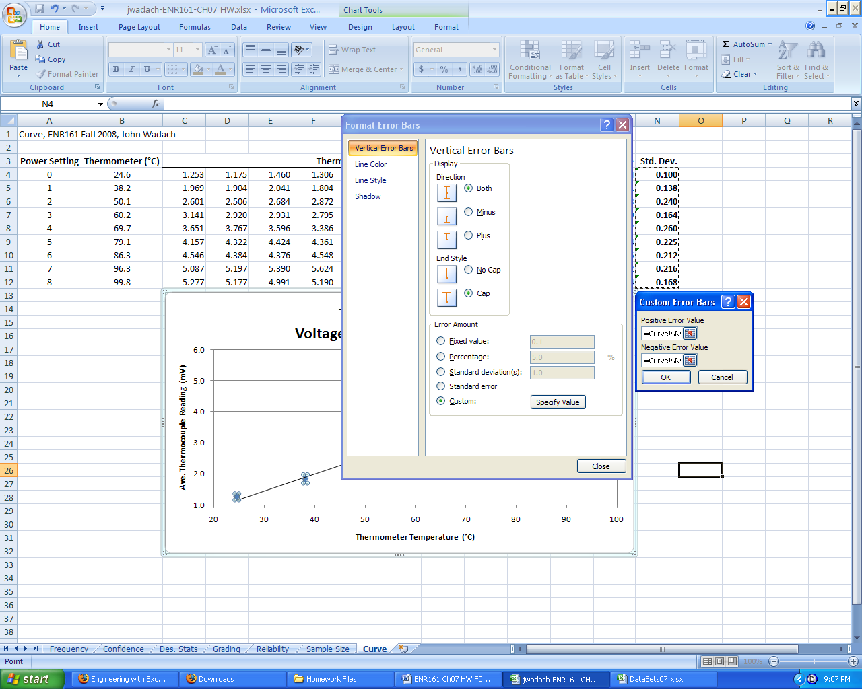

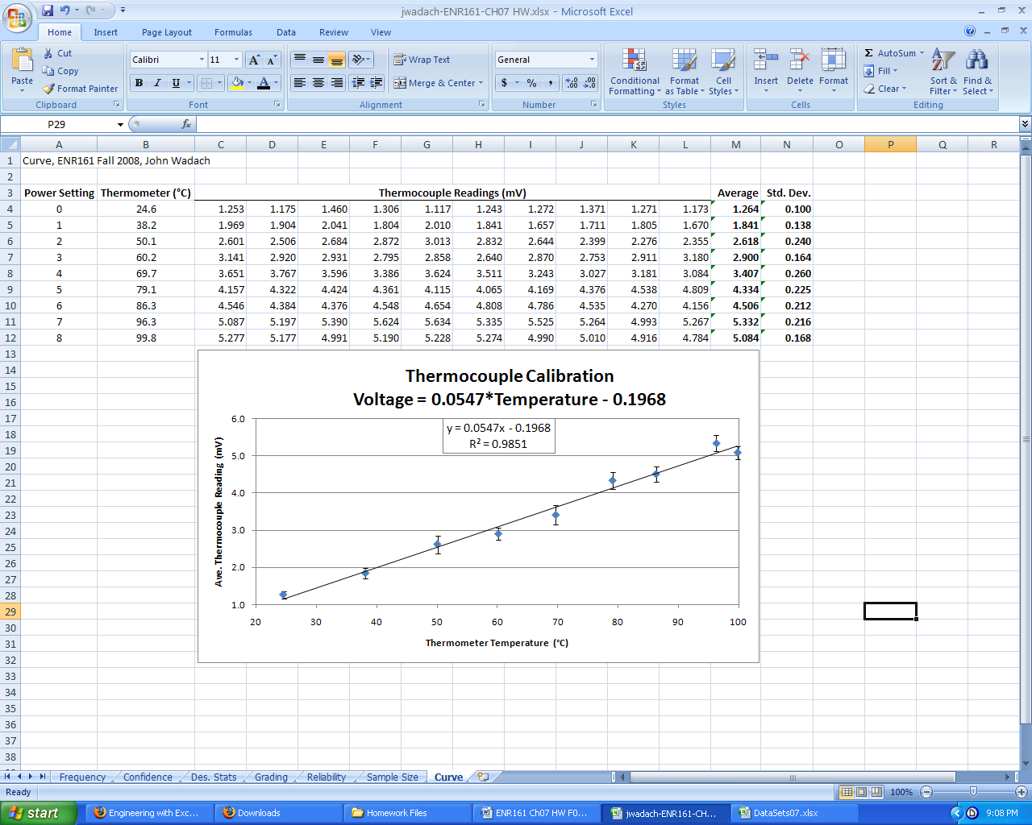

Notes